Updated 7/22/24

**Crews Lake Raiders**

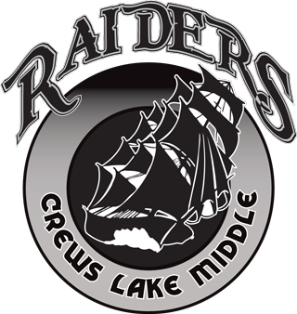**Cheerleading**

**Tryouts**

**2004-25 School Year**

Athletic Participation Packets uploaded to www.athleticclearance.com

Information must be uploaded and student must be cleared to try out.

Tryout Dates:

August 14th & 15th – after school until 4:30

Meet in the gym

Tryout Items – Shirt, Shorts, Running Shoes, Water Bottle any medical items you need