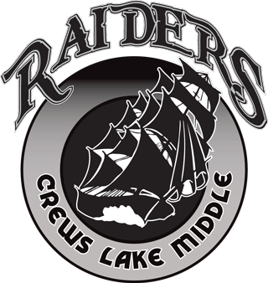

Crews Lake Middle School
Raider Athletics

Raider Athletic Information and dates for tryouts can be found on our Crews Lake Athletics website at https://clms.pasco.k12.fl.us/athletics/ while physical, participation forms and information are on Pasco County Schools Athletic Website at pasco.k12.fl.us/athletics/
Sixth, Seventh, and Eighth grade students can tryout for sports. Prior to conditioning and tryouts, students must upload all forms and complete all videos on the Athletic Clearance website (listed below). Students cannot participate in tryouts if this is not completed FULLY! It is strongly advised that students turn in their paperwork a week early to make sure everything is completed. Students must also have a 2.0 GPA in their previous semester in order to participate. If a student is selected for a sports team, an athletic fee must be paid for their participation. There is no fee for tryouts. Fees are shown on the reverse side of this paper.

Sports and Seasons
Football – Tryouts: 8th grade – August 7, 7th grade – August 8, 6th grade – August 9, Make ups are held on August 13. All are at 2:30pm or after school until 5pm, meet in the gymnasium.
Cheerleading – Tryouts are August 14-15 after school until 4:30pm in the gymnasium.
Girls Volleyball – Tryouts: 8th grade – August 14, 7th grade – August 15, 6th grade – August 16 at 6:30am in the gymnasium.
Boys Soccer – Tryouts in October. Dates will be listed on website at a later date.
Girls Basketball – Tryouts in October. Dates will be listed on website at a later date.
Girls Soccer – Tryouts in January. Dates will be listed on website later.
Boys Basketball – Tryouts in January. Dates will be listed on website later.
Boys and Girls Track – Tryouts in March. Dates will be listed on website at a later date.

Athletic Participation Packet
All forms must be uploaded to the Athletics Clearance at athleticclearance.com
Uploads include:
- EL2 (Physical Evaluation) – 5 pages – Completed by doctor, parent, and student
- Pasco Athletic Participation Form – 1 page – completed by parent, student and notarized
- Completion Certificates for free Videos from nfhslearn.com – 3 videos – Concussion for students, Heat Illness, and Sudden Cardiac Arrest
- Forms listed above as well as all information on athletic clearance must be completed and student must be cleared in order to tryout.

The Pasco County Athletics Website has instructions and FAQs on their webpage
Any questions please email the Athletic Director, Robert Petrucci at rpetrucc@pasco.k12.fl.us

